**Question 1**

One of the Shneiderman's 8 golden rules of interface design is *"Strive for consistency".*

(a) Explain what this golden rule means.

(b) Explain what you or your group **must do** in order to apply this guideline to your HCI assignment (i.e. your HCI assignment’s prototype).

1. Consistent sequences of actions should be required in similar situations; identical terminology should be used in prompts, menus, and help screens; and consistent commands should be employed throughout.

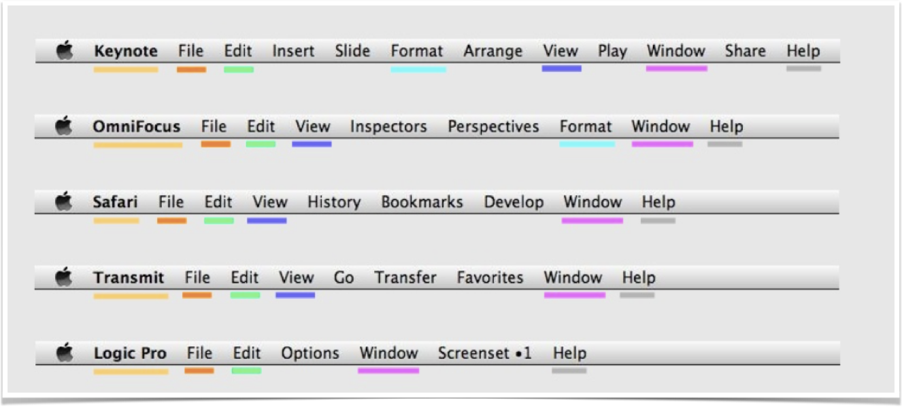

We have different types of application running on mac book systems, here , these set of applications shared the common menu bar sich as file, edit, view, window, this can help us to perform the similar task in different application, when we used the different application software here, we can expect the similar functionality among these set of menus, reduce the need to relearn again. File menu items (save, open), edit (cut, copy, paste)

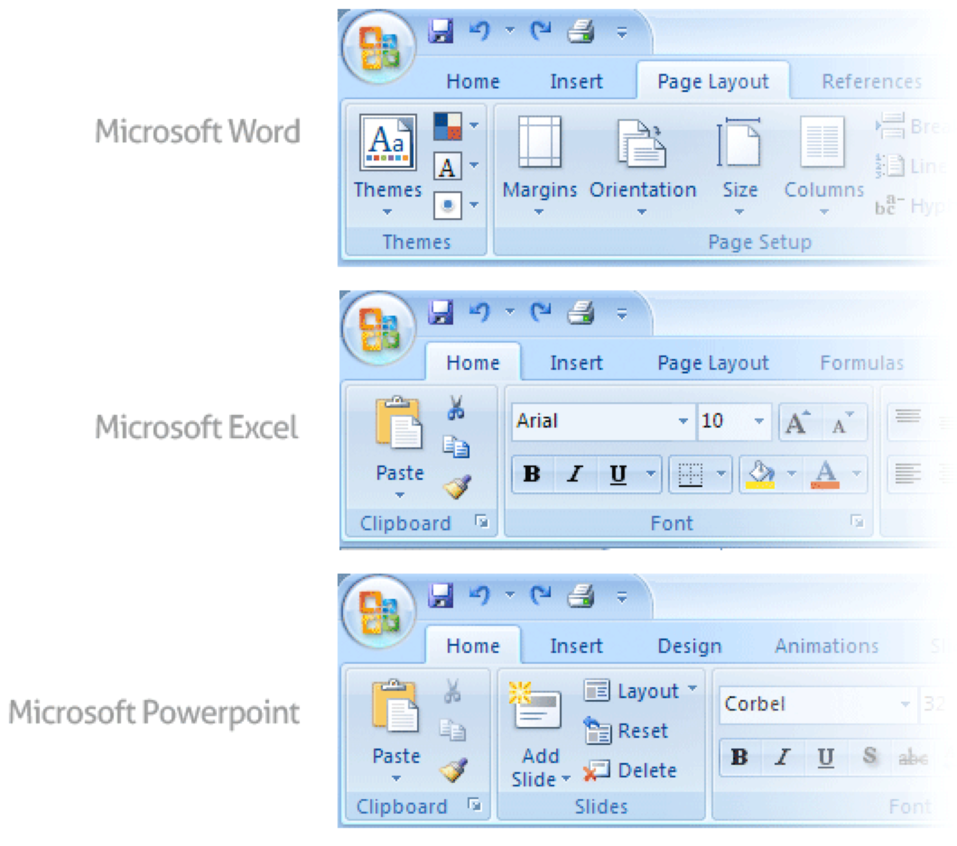

Microsoft applications software word, excel, power point shared the same set of ribbons here, common items and common task, reduce the need to relearn again.

1. Date format, terminology (prev, next), shortcut key (Copy,Cut,paste), * for mandatory fields, font size, button sequence, error message, dialog location on screen at the center.

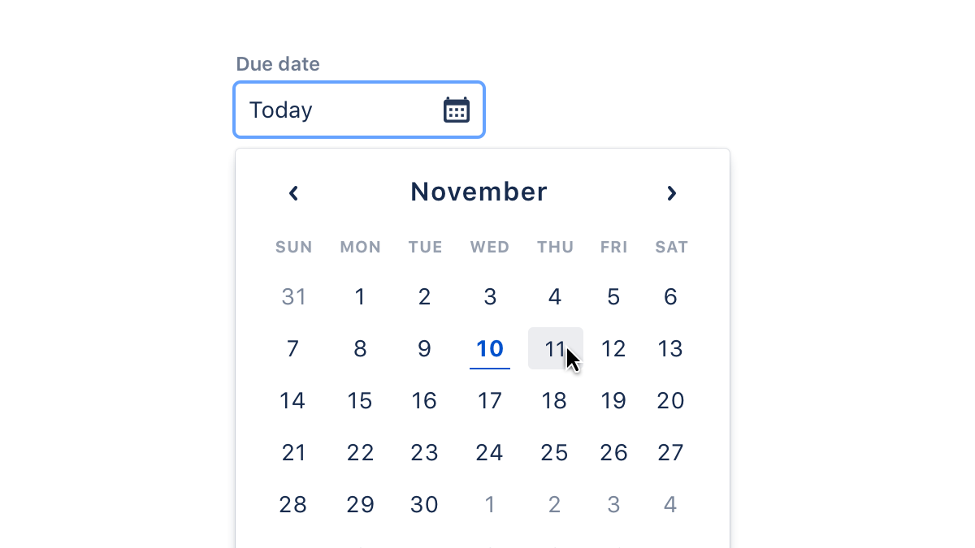

**Use date calendar controls for the inputs**

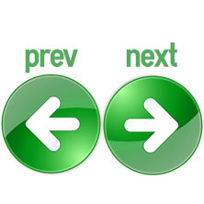

**These icon should be placed together**

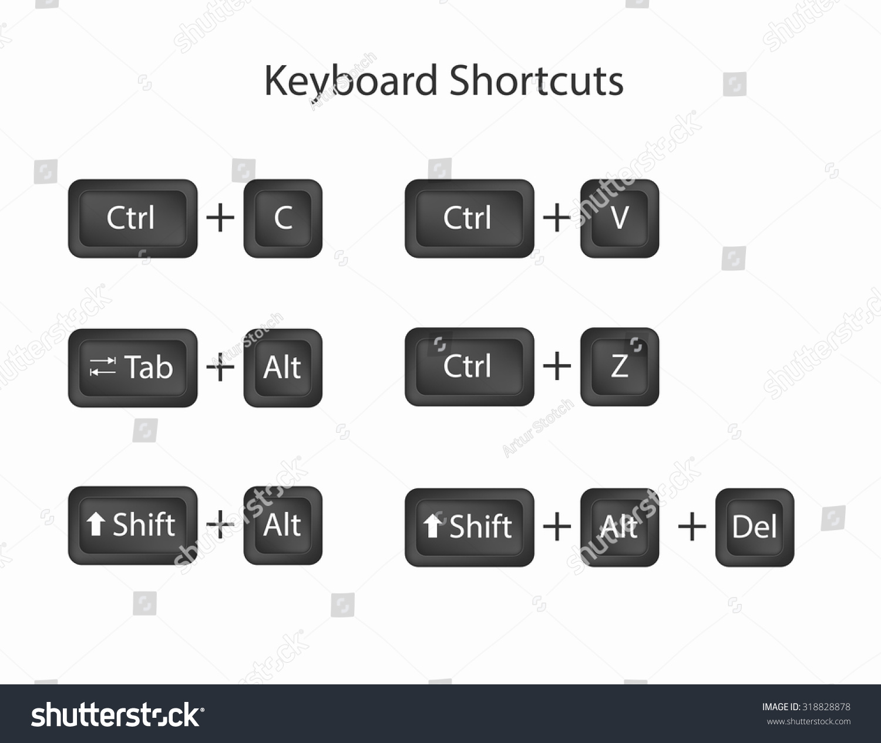

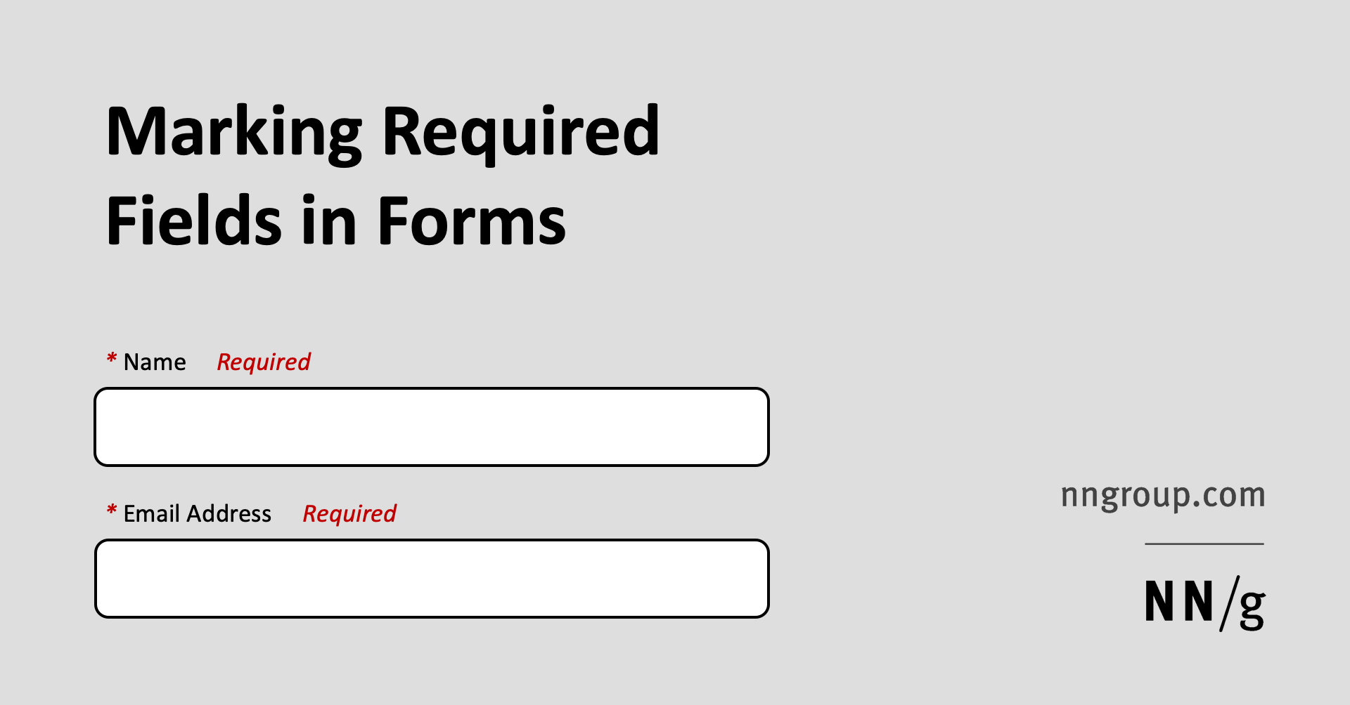

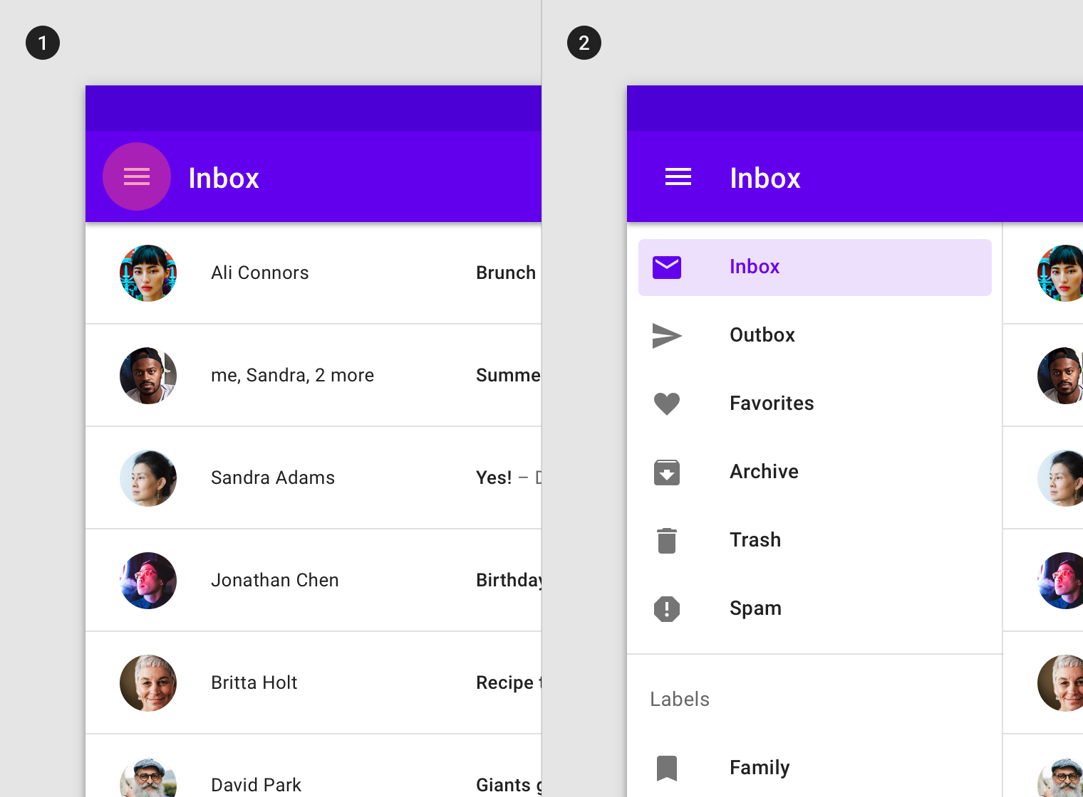

<https://www.interaction-design.org/literature/article/shneiderman-s-eight-golden-rules-will-help-you-design-better-interfaces>

**Question 2**

(a) Explain in details the good things and the bad things about the *Shneiderman's 8 golden rules* of interface design.

(b) In your opinion are these UI design guidelines useful to software developers? Justify your answer.

1. Pros – Provides good starting point for designing a usable UI since can be applied widely. Can be used to evaluate completed UI, used as checklist to evaluate the usability of the software

Cons – it does not tell designers how exactly to apply them in designing a UI. Needs to be interpreted based on user’s environment and tasks. Eg. Translated into more concrete design rules such as screen title to be displayed on left corner. Not much examples given , depend on how we interpret them, different people interpret in different way, we need an example how these principles can be applied, sometimes we know the principles, but we don’t know how to applied them, these principles can be too abstract.

1. Yes, they are. They help remind developers to focus on designing UI based on these basic rules besides understanding the user needs. Though they might have limitations where it does not work in certain environment or tasks. For example, developers have to consider the trade-off between designing a UI for good learnability or for efficient task flow. For efficient task flow, command line interface application are much better compared with GUI applications. , mouse click VS short cut keys or command line.

**Question 3 *(Present your answers using PowerPoint slides)***

1. Download and read the article “*The Case Against User Interface Consistency*” by Jonathan Grudin. (read pages 1164-1167 is enough).

<http://research.microsoft.com/en-us/um/people/jgrudin/publications/cognitive/consistency/cacm1989.pdf>

Based on the above article, mention an **example of** **one of the best designs that violate the guideline “*consistency*”**. Explain your answer.

1. Give an example **(own example)** of a good UI design that violate the guideline **“***consistency***”**. Explain your answer.
2. 3 types of consistencies:
   1. Internal consistency – Eg. Consistency within a program.
   2. External consistency – Eg. Consistency with other similar programs or conventions such as ms word, ms excel, ms power point
   3. Correspondence of interface to familiar features outside of the computing world – Eg. By using metaphor or analogy to an objects, attributes or relations. For example save icon, print icon, cut , copy and paste icon

Example: Keyboards violates the consistency of having letter arranged in an alphabetical ordering. Having keys arrange in an alphabetical way would make it easier for new learners to use the keyboard at the cost of impeding typing efficiency. Hence the keyboard violates this consistency on purpose in order to cater for user focusing on typing.

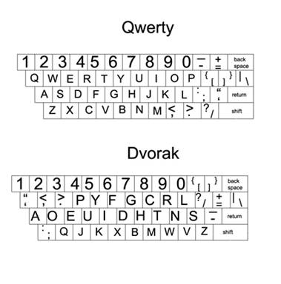

We don’t need to remain consistent all the times, sometimes we need to violate the consistency rules here to come out with the better designs

Windows 8 introduced a completely different user interface to the operating system, and Windows 8.1 builds on that. The Windows 8/8.1 user interface is called the Modern interface, and it differs from the traditional Windows desktop. The desktop that fills your screen is part of Windows, as is the taskbar at the bottom of the screen and the big menu that pops up when you click the Start button. Later in window 10 , they go back to desktop styles rather than modern interface.

1. “Delete” command should be different from other button design/layout to prevent users from accidentally deleting files. For instance, the button can be coloured differently or placed far away at an irregular corner.